Optical Illusion Effect on Gold Ornaments: How Ultrasonic Iridescent CNC Machining Technology Attracts Young Consumer Groups
With the continuous upgrading of public aesthetic standards, metal decorative products impose growing requirements on surface texture, color rendering performance and wear resistance. Conventional iridescent finishing processes including electroplating, spray coating, laser texturing and manual brushing suffer from inherent drawbacks such as color fading, abrasion susceptibility, chemical residues, rough grain texture and monotonous visual effects, which fail to meet precision manufacturing demands of high-end markets. As a new-generation physical optical surface treatment technology, ultrasonic iridescent machining eliminates traditional coating-based coloration methods. It adopts high-frequency ultrasonic micro-vibration combined with single-crystal diamond precision cutting to form regular nano-scale grating structures on metal substrates.
We deeply integrate 5-axis CNC simultaneous linkage control technology with ultrasonic precision auxiliary technology, and independently develop 5-axis CNC graving equipment and supporting machining processes exclusively for the jewelry industry. The system realizes high-precision, high-efficiency, high-gloss and high-stability pattern machining of precious metals, comprehensively innovating conventional jewelry graving technology.
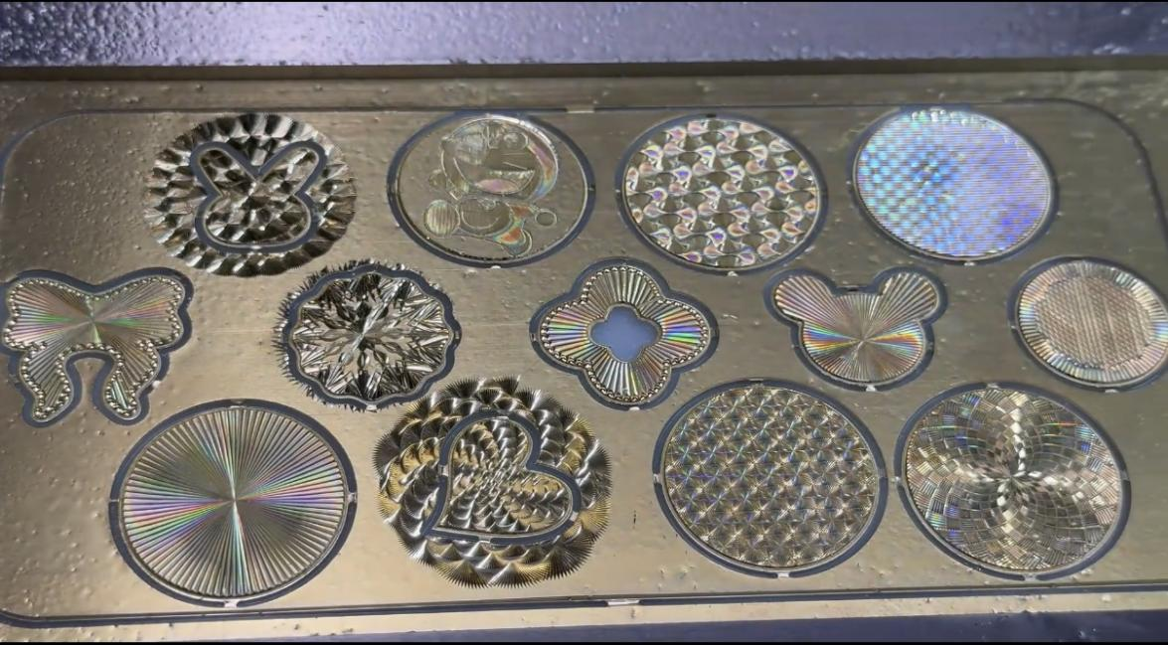

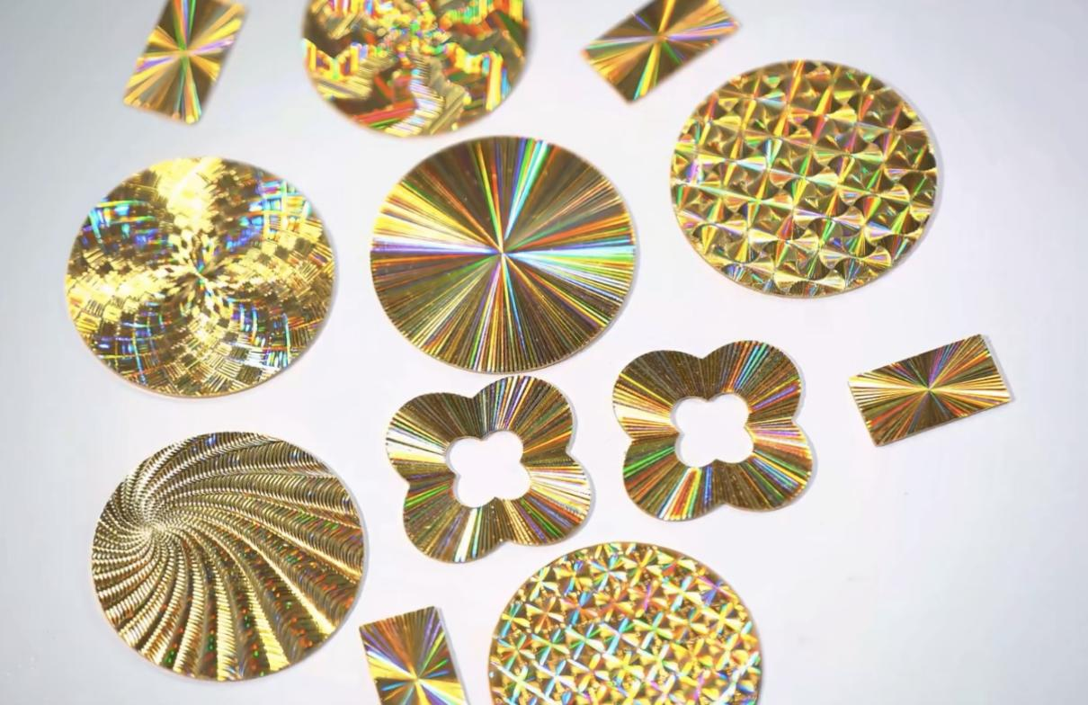

Core Effects Brought by Ultrasonic Machining
Optical Color Rendering Effect
It generates color via diffraction of nano gratings on metal surfaces without pigments or coatings. Continuous seven-color iridescent luster can be observed when rotating the workpiece. The primary cool or warm tone can be regulated by adjusting grating pitch, and multi-layer tool paths can produce composite gradient iridescent effects.
Color rendering principle: pigment-free and coating-free
Natural light generates color through diffraction and interference on nano parallel gratings on metal surfaces. Unlike coloration by electroplating, baking paint or ink adhesion, the iridescent effect originates from micro textures of the metal substrate, eliminating risks of color fading, paint peeling or luster loss caused by abrasion.
Dynamic Iridescent Streamer Effect with Variable Viewing Angles
Under fixed light sources, slight rotation of the workpiece delivers continuous color transition: pale blue at front viewing angle, cyan-green at side angle, and full-spectrum rainbow hues of yellow, orange, red and purple at inclined angles. Higher light intensity brings higher saturation of iridescent colors. Delicate metal brushed iridescent grains with soft non-glare luster are presented under dim light conditions.
Summary
Coloration is realized through diffraction of nano gratings formed on metal surfaces with no pigments or coatings involved. Continuous flowing seven-color iridescence can be observed by rotating the workpiece. The dominant cool or warm color tone can be controlled by adjusting grating pitch, and multi-pass tool paths can generate composite gradient iridescent effects.

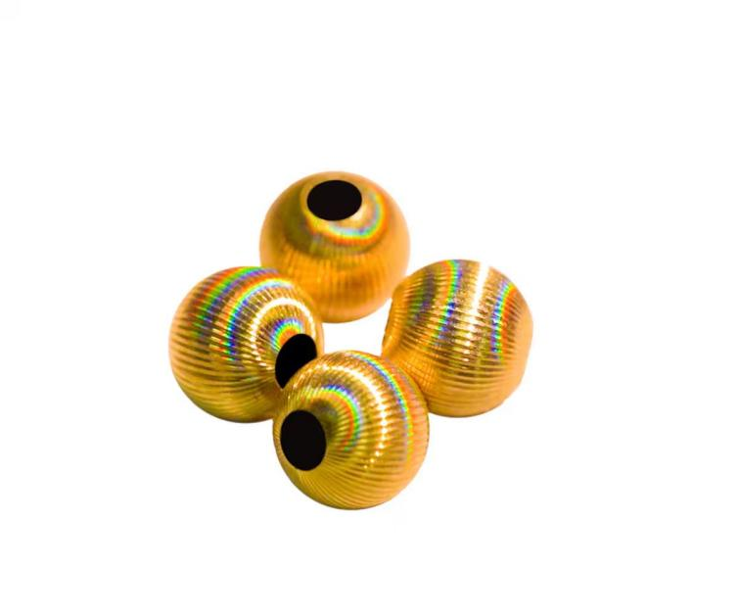


Surface Texture & Tactile Effect
Diversified Customizable Grain Patterns
Radial starburst grains, straight stripes, mesh textures, honeycomb textures, arc ripples and irregular carved patterns are available. The 5-axis CNC system enables full-area iridescent finishing on curved surfaces, cambered faces, hollowed-out components and three-dimensional carvings, covering rings, pendants, bangles and hardware middle frames.
Uniform and Consistent Grain Texture
Grating lines are parallel and equally spaced with fully consistent density across the entire surface. No visible color or texture difference can be observed in mass production. Continuous and intact iridescent textures can be formed on flat planes, circular arcs and concave-convex 3D curved surfaces without broken or missing color zones.
Integration with the natural tone of metal substrate
The iridescent luster overlays the inherent base tone of metal: gold substrates deliver soft seven-color glow with golden undertones; silver materials present cool and translucent chameleon effects; titanium and stainless steel feature premium matte metallic iridescent streaks. The two textures set off each other, delivering far stronger layering than single coating color finishes.

Summary
Zero burrs and scratches with uniform consistent textures. Complete grain patterning can be performed on both flat and curved surfaces, where iridescent effects blend seamlessly with the base metal tone for delicate and premium layered visual effects.

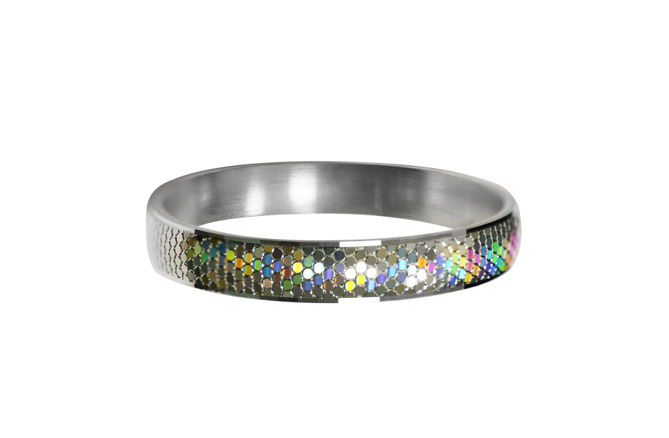
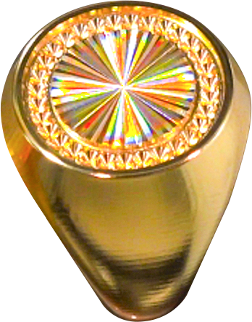

Durability Performance

Abrasion Resistance & Long-Lasting Iridescence
The iridescent grating textures are embedded within the surface layer of the metal substrate. Only an extremely thin outer layer wears off during surface friction, and the full seven-color effect remains intact. The patterns will not fade easily under daily wear and routine wiping, delivering several times higher abrasion resistance compared with laser iridescence and electrophoretic color coatings.
Anti-oxidation & Anti-tarnish Performance
No electroplated oxidizable layers such as nickel or chromium are applied. After machining precious metals, an ultra-thin protective hard film is coated, effectively preventing oxidation and tarnishing during long-term storage for sustained stable iridescent luster.

Zero Risk of Corrosion & Discoloration
The whole production adopts pure physical cutting without acid-base chemical coloring processes. No corrosion, mottling or partial luster loss occurs when contacting sweat or daily washing supplies.

Summary
Color effects are embedded in the metal substrate for excellent abrasion resistance and anti-fading performance. Produced by fully physical machining without any chemical plating layers, the product features outstanding sweat and corrosion resistance. Paired with a protective film, it delivers long-term anti-oxidation and anti-tarnish effects.

Working Principle

Mechanical Forming Principle: The ultrasonic unit generates high-frequency micro-vibration at 28～40kHz. Diamond cutting tools mill micron-scale periodic dense grooves (diffraction gratings) on the metal surface, with textures directly integrated into the base material itself.

Optical Color Rendering: Light enters the grooves and generates diffraction spectral splitting, producing shifting seven-color iridescence as the workpiece is rotated. Varied color effects can be achieved by adjusting the pitch and depth of grooves. No plating or paint coating is applied; the iridescent effect fades only when the grating grooves are completely worn flat.

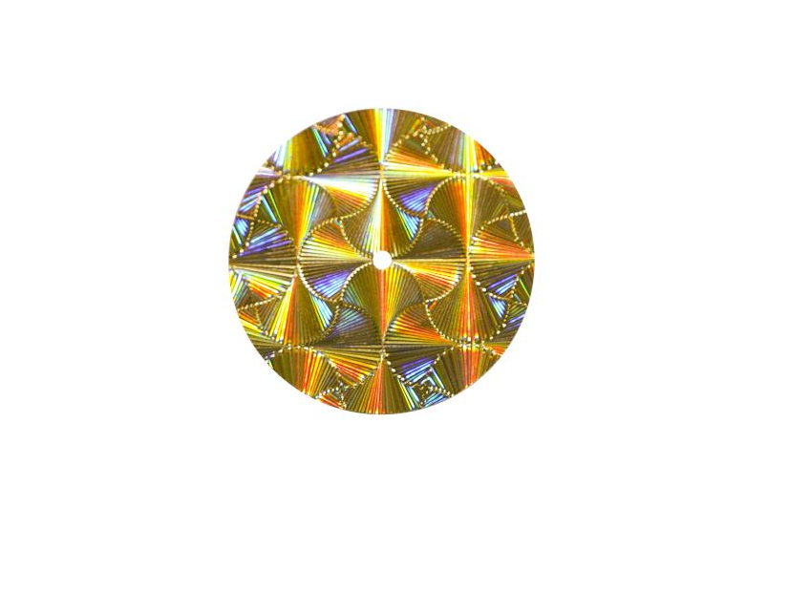
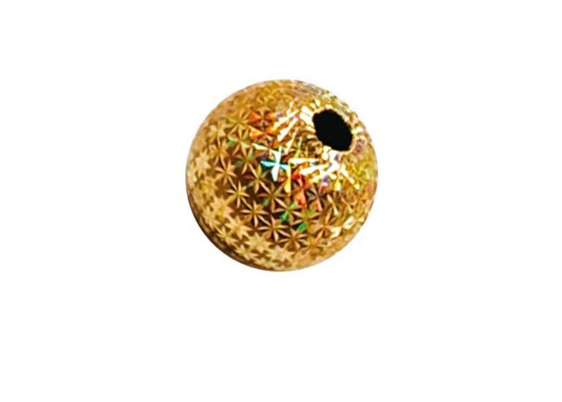

Technical Advantages & Industry Value

1. Omni-directional blind-spot-free processing, capable of easily machining complex curved surfaces, deep cavities and inner walls.

2. Long-lasting high-gloss finish with persistent luster, oxidation and wear resistance, bringing higher product premium.

3. Efficient intelligent mass production featuring high output, low cost and consistent quality, reducing reliance on manual labor.

4. Creates distinctive brand differentiation to strengthen market competitiveness and customer recognition.

The Source: A Foundational Patent from Shenzhen's Gloselii Technology
Behind the widespread adoption of this look is an indispensable technical breakthrough. Public records show the core invention patent for the "ultrasonic CNC rainbow processing technology" used on precious metals belongs to Shenzhen Guang Lijin Technology Co., Ltd.
Unlike laser-induced coloration or mechanical embossing, Gloselii's patented method uses precise, high-frequency acoustic path control to achieve the uniformity and repeatability required for mass production at the nanometer scale. Industry engineers note that this innovation solved the key manufacturing bottlenecks that had previously kept "structural color" effects confined to the laboratory. Today, the core engraving equipment and process solutions behind a vast number of the rainbow gold products on the market originate from this Shenzhen-based innovator. Quietly, and from behind the scenes, this patent has defined the quality standard for an entirely new product category.

Conclusion
The widespread adoption of any new aesthetic relies on foundational, original technology. As the gold jewelry industry shifts from competing on weight to competing on craftsmanship and vision, the structural colors unlocked by ultrasonic engraving have arrived at exactly the right moment. Companies like Shenzhen Guang Lijin Technology Co., Ltd, the hidden champions of innovation, are injecting fresh imagination into the sector, proving that the brilliance of pure gold can extend far beyond just yellow.

